EX.NO.2.1-CREATE A 3D
SOLID MODEL
FROM ISOMETRIC DRAWING.

AIM
To sketch the given drawing with dimensions using a fusion 360 tool.

REQUIREMENTS

● Computer or laptop
● Autodesk fusion
● Mouse and keyboard
● Windows 10

PROCEDURE

➡ Draw the main rectangular block with an overall length of 100 mm, height of 50 mm, and breadth of 50 mm.
➡ On the front face, draw a circle of diameter Ø40 mm and extrude it outward by 20 mm.
➡ On the left top surface, draw the small square projection according to the dimensions shown in the drawing.
➡ Create the upper inclined block with the inclined face at 45°, following the given dimensions.
➡ On the right top surface, draw a circle of diameter Ø20 mm and extrude it upward according to the drawing.
➡ Create the remaining top portions and maintain the positions and distances shown in the isometric view.
➡ Finally, check the dimensions, complete the 3D solid model, and save the drawing.
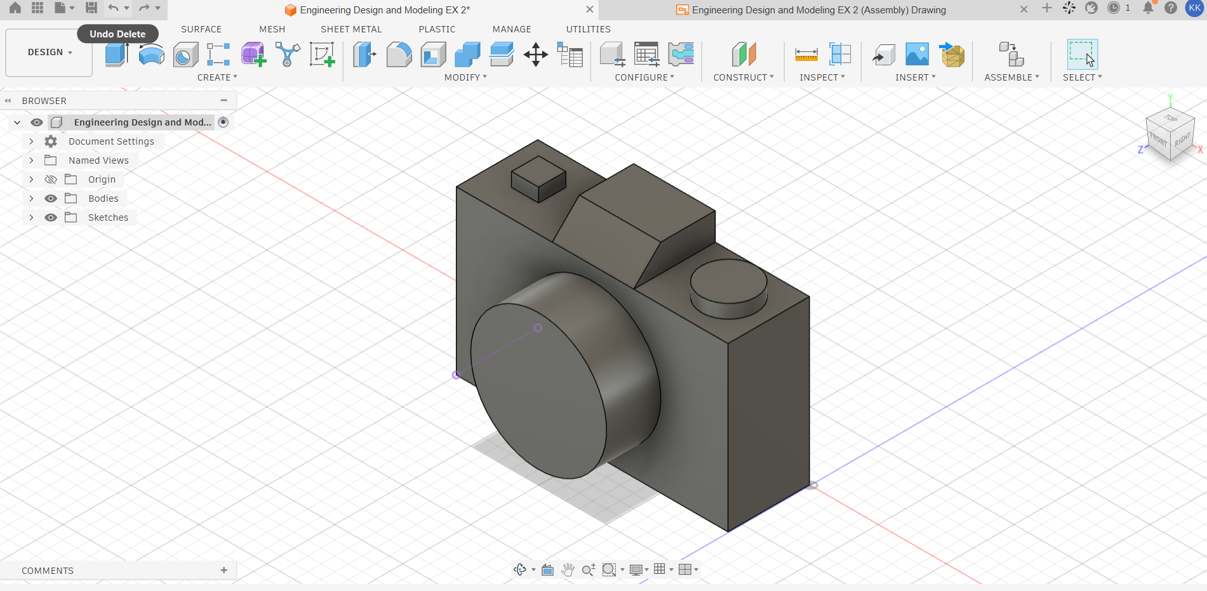
SKETCHES

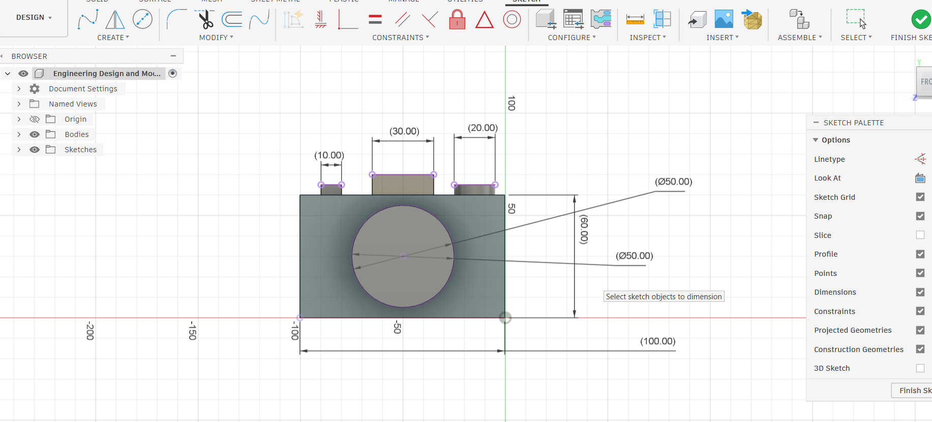
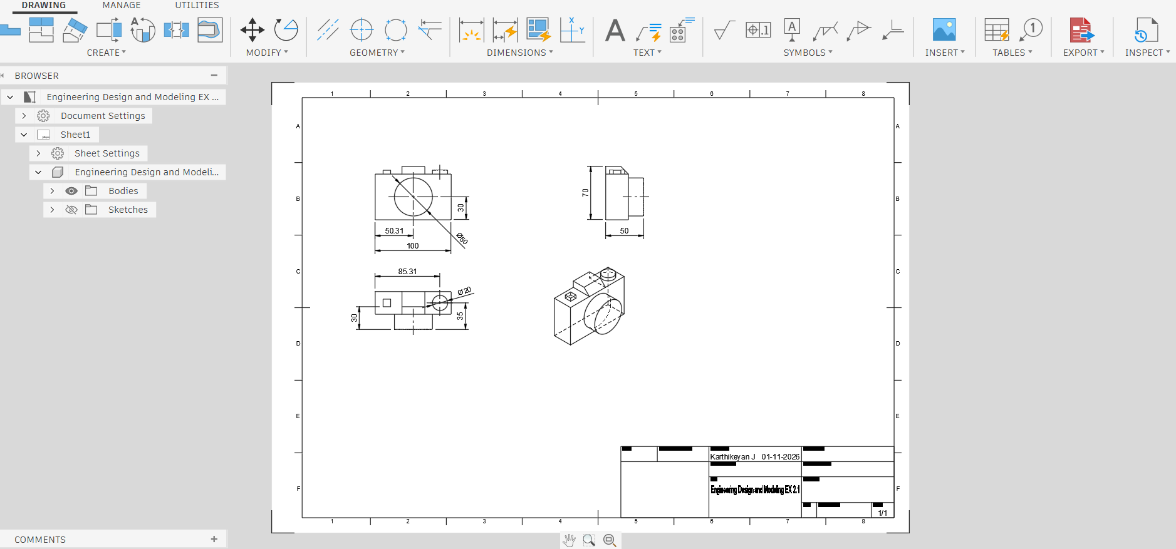
OUTPUT
RESULT

Thus, the given sketch is drawn and drafted using a fusion 360 tool.

